Uncharted: Low-Fidelity Prototype

# Team

Raissa Largman: Development, Design

Kate Wendell: Manager, Design

Moustafa Asfour: Development, User Testing

Matt Taylor: Development, Documentation

# Introduction & Mission Statement

Mission Statement: “To simplify and improve travel planning by helping you discover new places that suit your preferences”

Travelers are inundated with information about destinations and itineraries that are often irrelevant to their tastes. We seek to delight student travel planners by helping them find exciting new destinations and suggested activities they love. We will only share the important details, preventing information overload and keeping the location and activities relevant to their stated desires.

The purpose of this experiment is to test our proposed system, which is presented to participants in the form of a paper prototype. The goals of testing include assessing pain points and strengths of the interface and gauge interest in and engagement with the application. Our team performed usability tests with three college students in our target demographic who were completely unfamiliar with the application and our team prior to their respective tests.

# 

# 

# 

# 

# Prototype Description

figure 1: geo-location filter screen figure 2: current filters screen

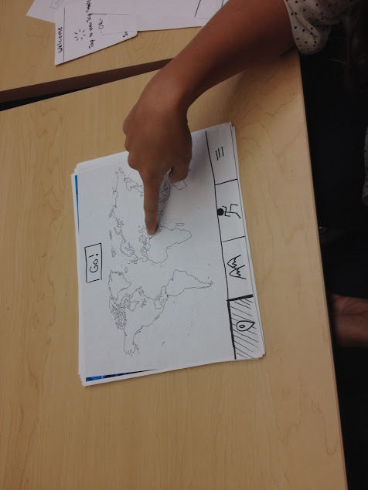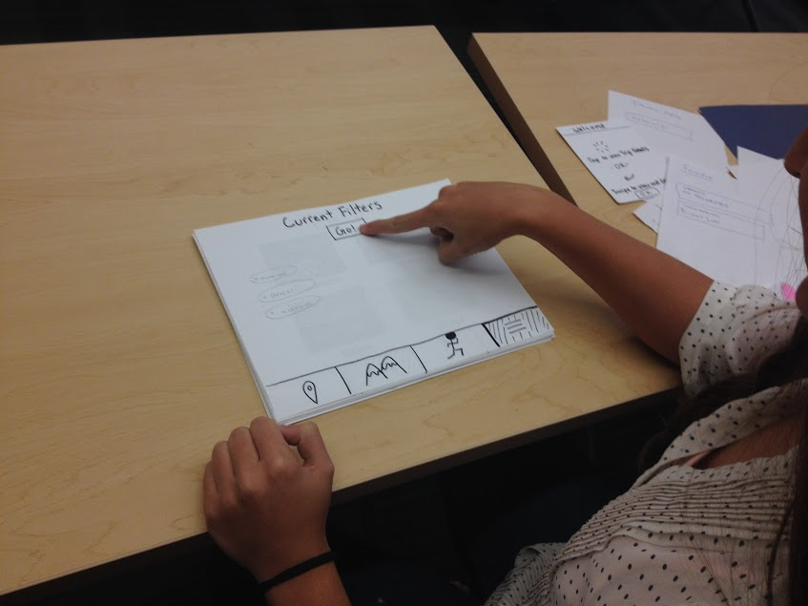

figure 3: settings filter screen figure 4: favoriting from Destination view

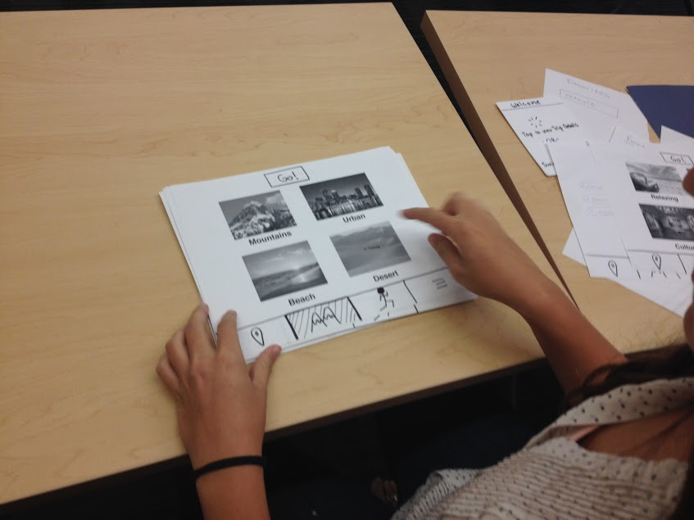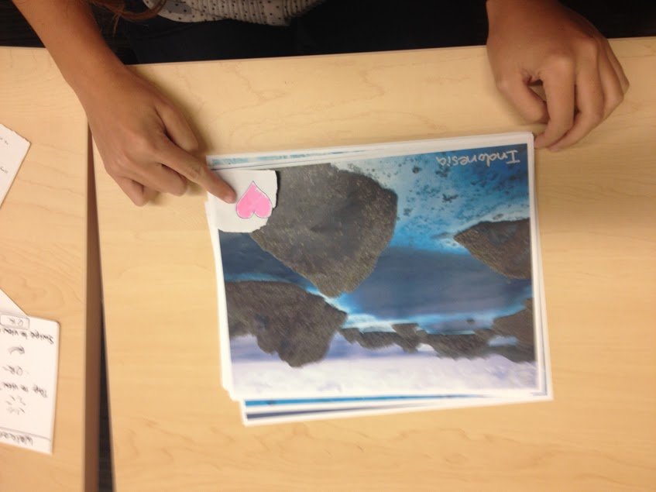

figure 5: favorites screen figure 6: Destination view

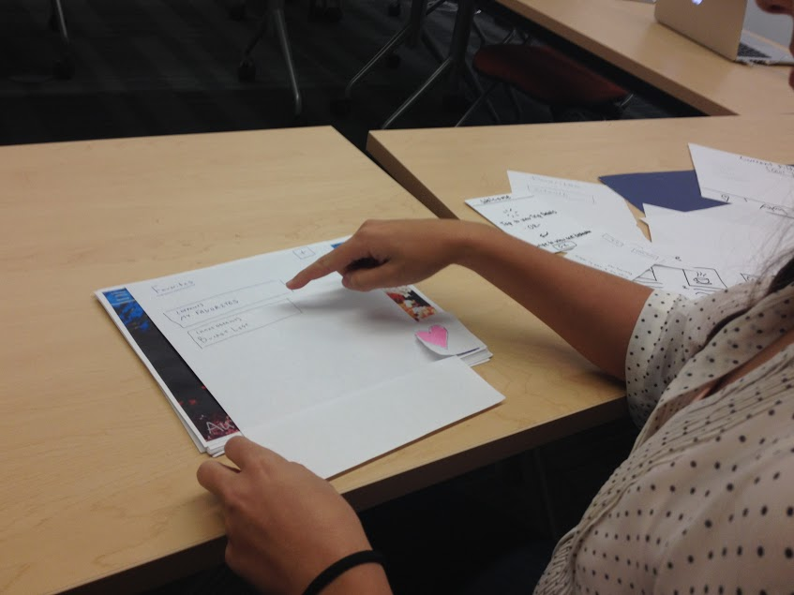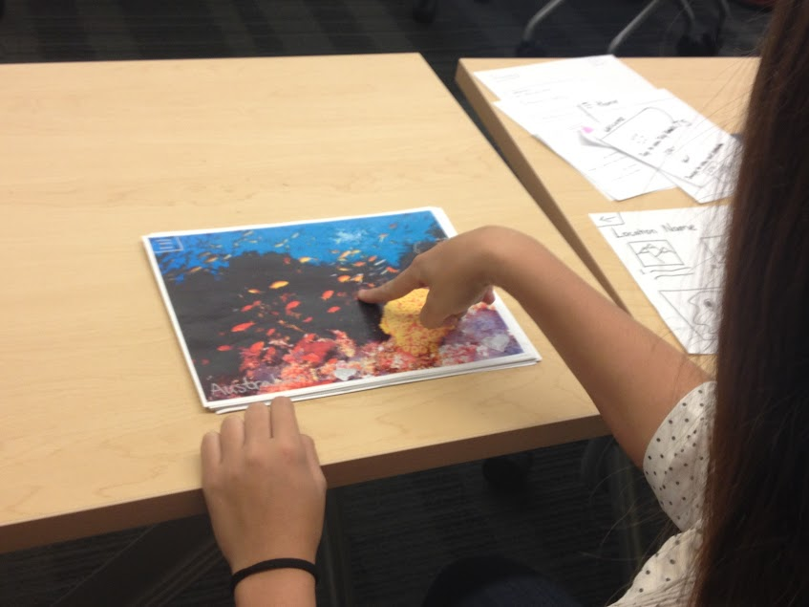

figure 7 a-e: a) Destination view b) Trip Details view c) Favorites view d) splash screens

1. Filter views from left to right: geo-location, setting, activity, current filters

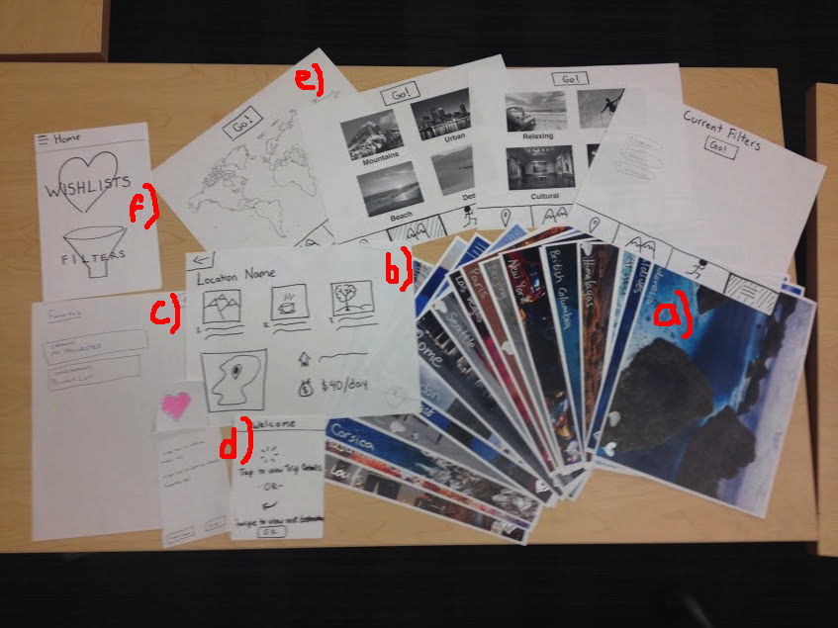

The paper prototype includes three main views: the Destination view and trip details (see figure 6 and figure 7a), Favorites view (see figure 5 and figure 7c) and Filter view (see figures 1, 2, 3 and 7e). When the application is first opened, a welcome screen with a quick tutorial on navigating is presented to the subject explaining that he or she can tap or swipe left (see figure 7d). From the Destination view, the subject can swipe right to view additional destinations, tap the menu button in the top-left corner to open the menu, tap the destination image for trip details (see figure 7b) or add the currently displayed destination to favorites by tapping or holding down the favorites button in the bottom right corner. If the button is tapped, the destination is added to a default favorites list. The first time the button is tapped, the user is presented with a window stating that the destination was added to favorites and that holding down the favorite button allows adding the destination to specific lists. If the button is held down, a view is displayed to the subject similar to the favorites view that allows him or her to add the destination to a specific list or create a new list to add the destination to. After the destination is added to a specific list or a created list, the user is returned to the Destination view.

From the menu view (see figure 7f), the user can access the favorites view and the filter view. From the favorites view, the subject can create a new list, view lists, change the default list and view trip details for destinations in lists. The trip details view (see figure 7b) presents three suggestions for activities, a recommended hotel or hostel, a map to show the location of the destination and an estimated budget per day for a trip to this destination. The filter view allows the subject to filter by geo-location, setting and activity type and also has a view for currently applied filters.

# Method

figure 8: subject having trouble with filters figure 9: facilitator with subject

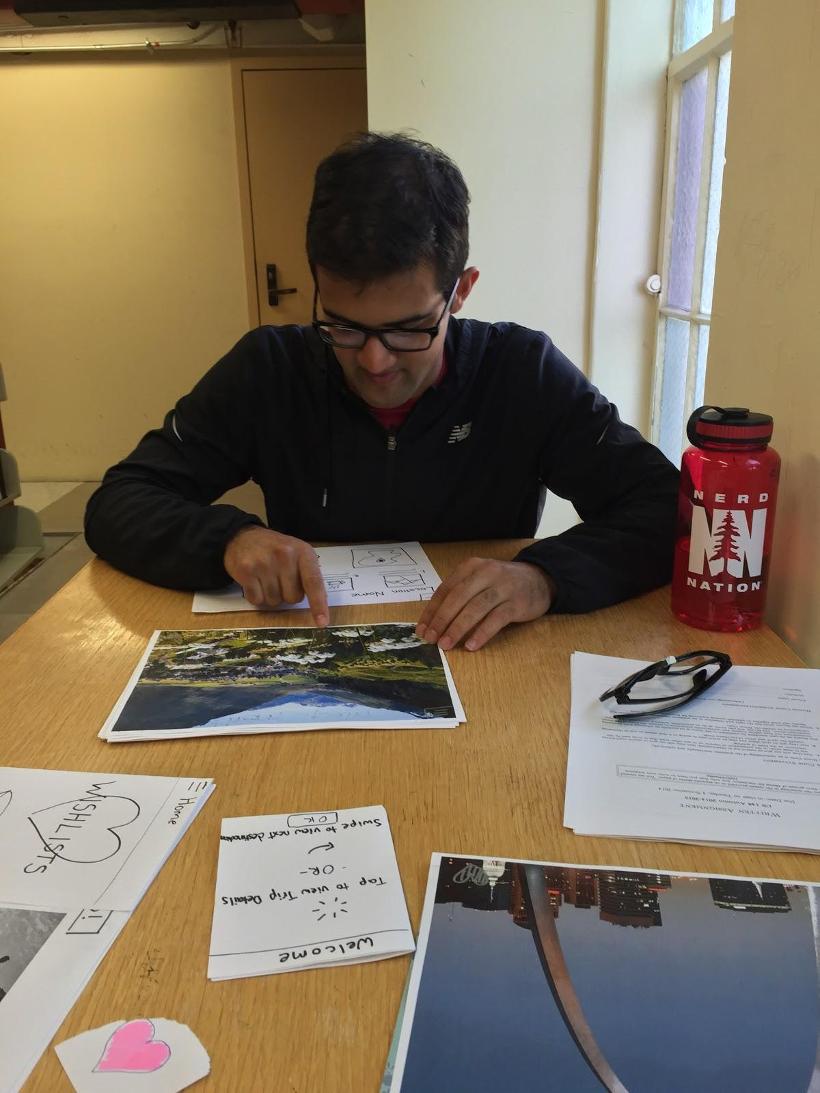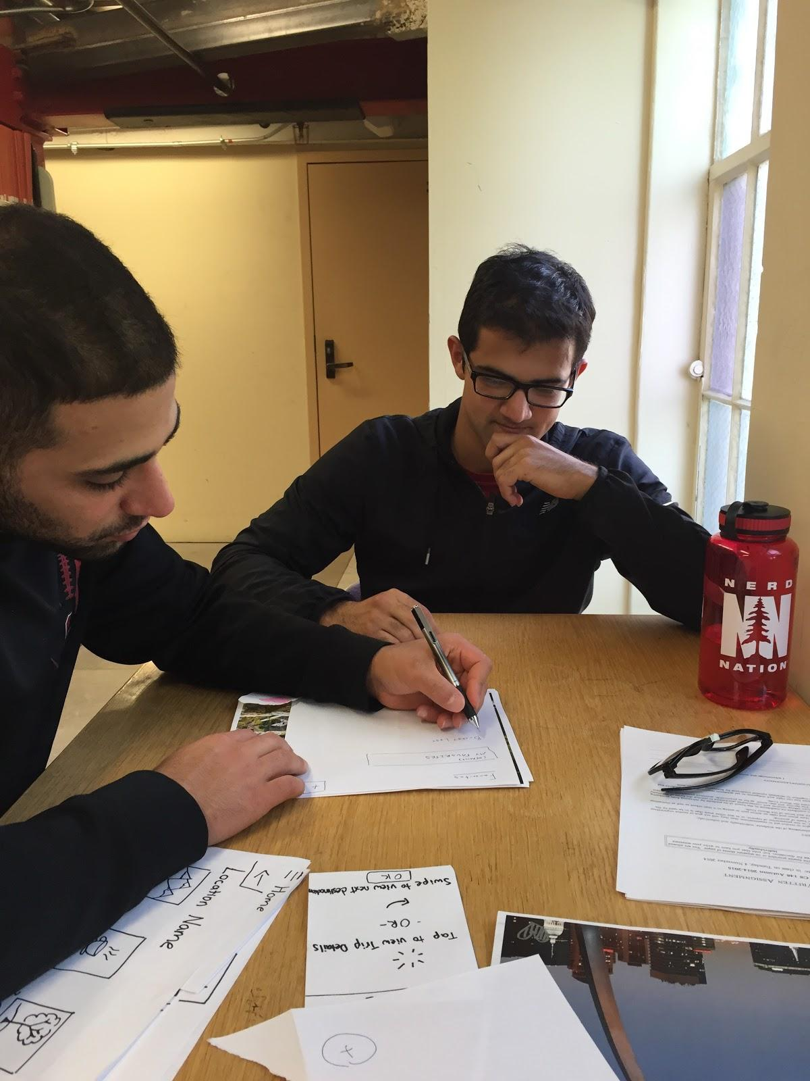

figure 10: subject in trip details view

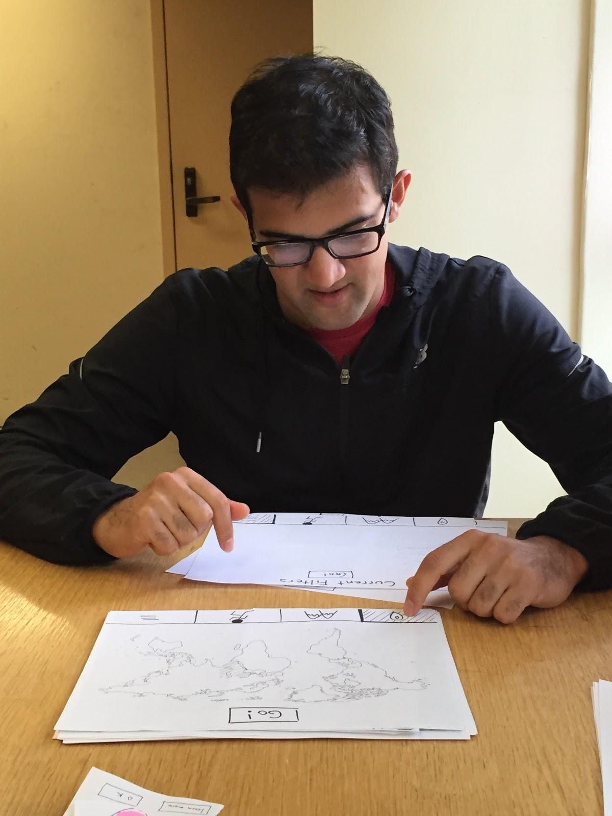

We selected the three participants for our experiment from our target audience of 18-25 year-old young adults who were frequent travelers and had engaged in trip planning prior to the experiment using resources such as TripAdvisor, Google search, etc. Subject #1 is a senior at Stanford majoring in Mathematical & Computational Sciences who had spent this past summer in Germany. Subject #2 is a freshman at Stanford majoring in Classics, while Subject #3 is a junior at Stanford majoring in Computer Science. All three subjects are avid travelers and have been on a trip within the past year. The test subjects were selected by being asked if they were willing to participate and have no relation to any Uncharted team members or the application development cycle we are currently in. The subjects were compensated with a Coupa drink of their choice for participating in the experiment.

Testing took place in neutral environments; subjects 1 and 2 were tested in a dining setting after lunch, while subject 3 was tested in the Bing Wing stacks of Green Library. Subjects sat at a table or desk and were presented the prototype before them to simulate using the application in a common student settings. The facilitator sat to one side of the subject (see figure 9), while the observers and computer sat on the opposite side to maintain the prototype as the only item in the immediate view of the subject and to provide a clear view of the test to the observers.

Our testing procedure began with getting the subject in the mindset of using the application by telling them that they are interested in finding travel ideas and destinations. Afterwards, we would start them off on an initial splash screen that is displayed when the application is first opened. From there, we let the subject probe the interface to discover the pathways from the current screen. When the subject navigates to a key screen (trip details, favoriting, filtering), we let them explore that screen to get an idea of what it offers. We then ask the subject questions like, “what do you see here?” and “what do you think you can do with this?” Once the subject has established an idea of what the function of that screen is, we then ask if it is what he or she expected to see given that they now know its purpose. Afterwards, given the purpose of the screen, we ask if it is want they would want or if it leaves something to be desired. After the subject had engaged in the three target tasks and interacted with their associated screens, we then asked about overall impressions, pain points and recommendations about the concept and interface.

For the experimental roles, Moustafa acted as the facilitator, Kate acted as the computer and Matt and Raissa acted as the observers. Subjects only interacted with Moustafa during the tests. We also practiced prior to our tests to streamline the computer’s role in the test, focus the note-taking of the observers and run through the script of the facilitator. Our test measures included both high and low-level data. High-level data included how easily the subject was able to transition between key screens once he or she engaged in one of the key tasks (trip details, favoriting or filtering) and the ease of use of each screen. Low-level data included how much time was spent on the filtering and favoriting tasks and how many words of praise or confusion were said during the test.

# Results

Our goal of having a largely visual/pictorial interface instead of a text-heavy one was well received for the most part. However, this made the filters pages unclear to many of the participants. The filters page was deemed generally too involved and confusing upon first arrival. There were too many filters and a price filter was not one of the available options. The icons were not easily identifiable and the placement of the go button led some to believe there was only one page of filters. Additionally, once filters were selected it was somewhat difficult to return to your current filters to edit or delete them.

The favoriting flow was also marginally confusing when first experienced. This is due to the difference between simply adding to the default list or creating a custom list, which was not clearly explained, and led to some participants becoming frustrated.

The participants responded well to level of detail provided on the trip detail page, but would have liked a way to take notes or edit the activities displayed on this page. A reference to the original picture shown on this page was also desired.

# Discussion

One of the largest areas of negative feedback was the filters area. Our mission states that we want to simplify travel planning, which is due to the fact that there is currently too much information or too many options available to somebody when deciding to plan a trip. However, our filters page does not currently meet this goal. We need to greatly simplify this area. The four current subpages add too much cruft to trying to filter and do not provide a clear flow. We should therefore remove some of these pages, such as the current filters page and have the current filters instead perhaps displayed on the top as you select them. The categories could also be merged or redefined because they caused confusion as to their definitions (difference between “nightlife” and “urban” was unclear, for example). Some suggested having only one filters page with checkboxes, or being able to scroll through possible filters and drag them about.

Another area to tackle would be the flow for when a person first favorites. We currently save immediately to the default list on the first favorite and display instructions on how to create custom lists. However, it was unclear whether the favorite had been saved at all, or if once saved it could be added to the custom list instead and moved around.

We have been able to minimize words so far in our interface, but this has actually led to some confusion, as in the filters page, so we might have to change this aspect of our UI a little bit in order to add clarity.

# Appendix

**Consent Form Below:**

The Uncharted application is being produced as part of the coursework for Computer Science course CS 147 at Stanford University. Participants in experimental evaluation of the application provide data that is used to evaluate and modify the interface of Uncharted. Data will be collected by interview, observation and questionnaire.

Participation in this experiment is voluntary. Participants may withdraw themselves and their data at any time without fear of consequences. Concerns about the experiment may be discussed with the researchers or with Professor James Landay, the instructor of CS 147:

James A. Landay

CS Department

Stanford University

650-498-8215

landay at cs.stanford.edu

Participant anonymity will be provided by the separate storage of names from data. Data will only be identified by participant number. No identifying information about the participants will be available to anyone except the student researchers and their supervisors/teaching staff.

I hereby acknowledge that I have been given an opportunity to ask questions about the nature of the experiment and my participation in it. I give my consent to have data collected on my behavior and opinions in relation to the Uncharted experiment. I also give permission for images/video of me using the application to be used in presentations or publications as long as I am not personally identifiable in the images/video. I understand I may withdraw my permission at any time

Name ______________________________________________

Participant Number ____________________________________

Date _______________________________________________

Signature____________________________________________

Witness name ________________________________________

**Demo Script:**

Thank you so much for meeting with us today, we really appreciate your time. We are looking forward to hearing your feedback on our design, so please don’t be shy with your criticism.

This is a paper prototype, but you can pretend it is an iPad application and click, swipe and drag as you usually would. Speak your thoughts and expectations out loud as much as you can. We carefully chose you as a participant as we think you fit the demographic of our target users, so if something doesn’t make sense to you please speak up, we’re hoping to make this an ideal tool for users similar to you.

To start, we want you to pretend you are researching destinations for a summer of traveling, please navigate through the application with that goal in mind.

**Process Data**

Severity Rating: 0=no problem, 1=cosmetic problem only, 2= minor usability problem, 3=major usability problem, 4=usability catastrophe

|  |  |  |  |  |
| --- | --- | --- | --- | --- |
| **Task/ Participant** | **One** | **Two** | **Three** | **Average** |
| Browse destinations and view trip details | 0 | 0 | 0 | 0 |
| Favorite a destination | 0 | 1 | 2 | 1 |
| Filter Destinations | 2 | 3 | 3 | 2.666 |